Project Development Phase
Model Performance Test

Date | 03 October 2026
Team ID | SWTID-2026-8647
Project Name | Implement Client Script & UI Policy (Incident)
Maximum Marks

Model Performance Testing:
Project team shall fill the following information in model performance testing template. Project-specific evidence is based on the five ServiceNow screenshots supplied for this Incident configuration.

S.No. | Parameter | Screenshot / Values
1. | Incident Form / UI Policy Configuration | 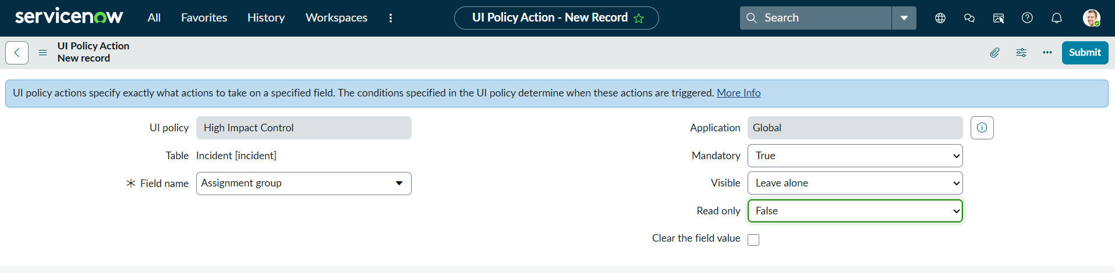  ServiceNow Incident form controls are configured using UI Policies and UI Policy Actions. The shared screenshots provide configuration evidence. Execution result: To be verified during implementation.
2. | UI Policy Actions | 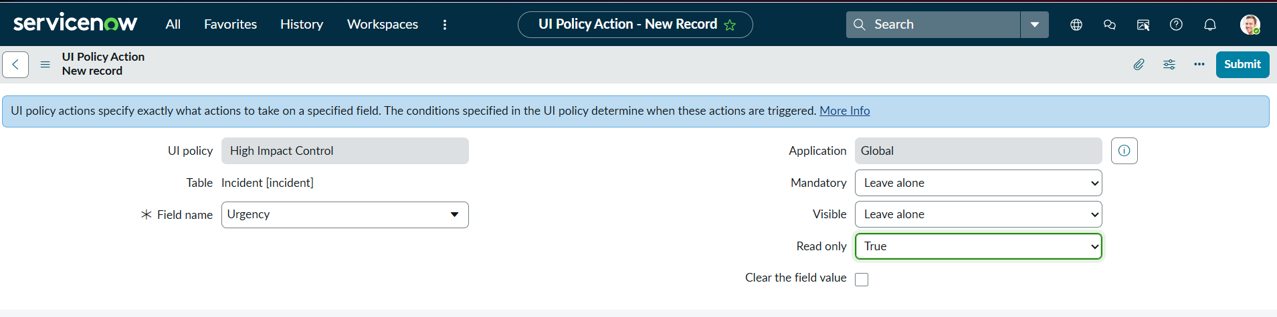  Assignment Group is configured as mandatory for the applicable Incident condition. Urgency is configured as read-only in the shown UI Policy Action. Execution result: To be verified during implementation.
3. | Client Script Configuration | 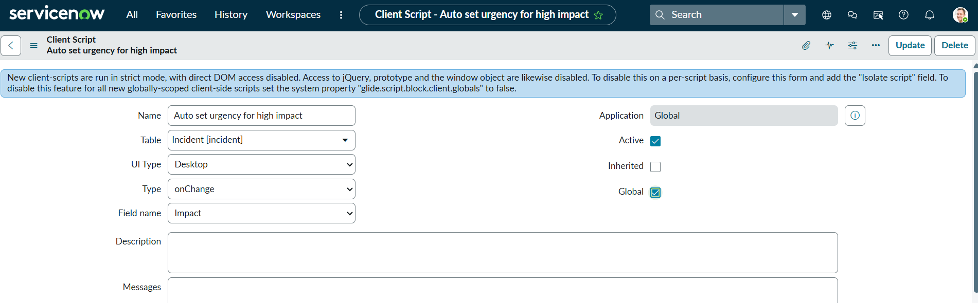  Client Scripts are configured on the Incident table for client-side form behavior. The supplied screenshots show the configured Client Script records. No JavaScript implementation is reproduced in this document.
4. | Client-side Validation | 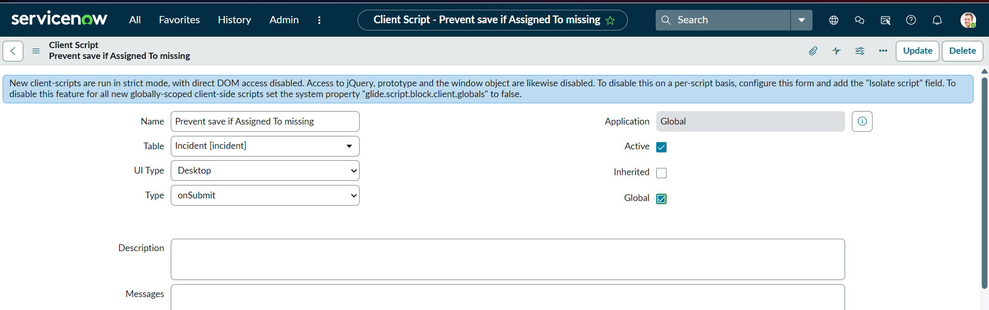  A Client Script configuration is used to support validation when required Incident information is missing. Validation result: To be verified during implementation.
5. | Field Behavior Control | 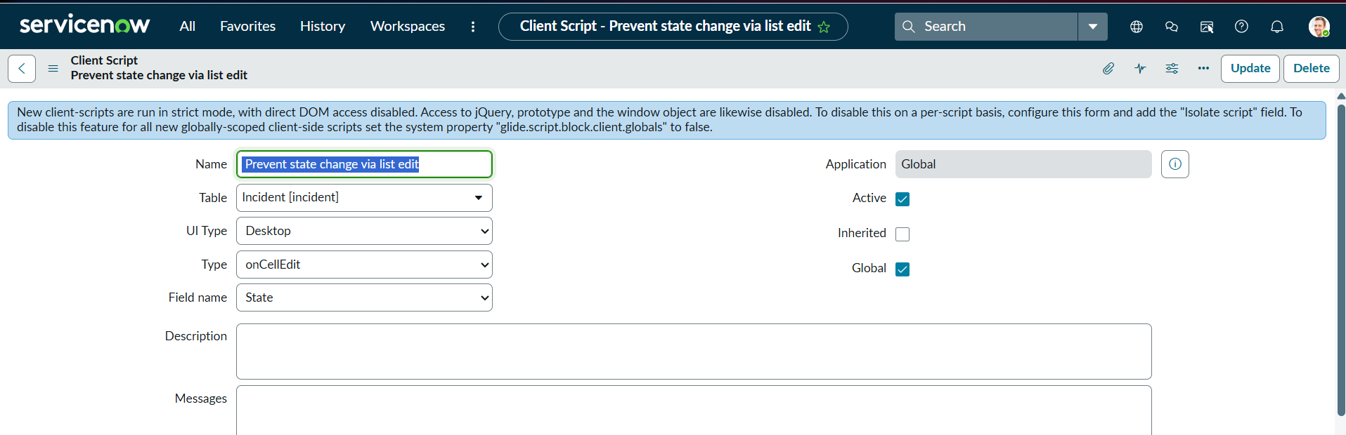  The configuration demonstrates mandatory and read-only field behavior and control of Incident state changes through client-side form configuration. Result: To be verified during implementation.
6. | Overall Incident Configuration | The project combines UI Policy Actions and Client Scripts to improve Incident form consistency and data quality. No dashboard/report visualizations are applicable to this configuration project.

